EC3401 NETWORKS AND SECURITY

PRACTICAL EXERCISES: 30 PERIODS

Experiments using C

1. Implement the Data Link Layer framing methods,
i) Bit stuffing, (ii) Character stuffing

2. Implementation of Error Detection / Correction Techniques
i) LRC, (ii) CRC, (iii) Hamming code

3. Implementation of Stop and Wait, and Sliding Window Protocols

4. Implementation of Go back-N and Selective Repeat Protocols.

5. Implementation of Distance Vector Routing algorithm (Routing Information Protocol) (Bellman-Ford).

6. Implementation of Link State Routing algorithm (Open Shortest Path First) with 5 nodes (Dijkstra's).

7. Data encryption and decryption using Data Encryption Standard algorithm.

8. Data encryption and decryption using RSA (Rivest, Shamir and Adleman) algorithm.

9. Implement Client Server model using FTP protocol.

Experiments using Tool Command Language

1. Implement and realize the Network Topology - Star, Bus and Ring using NS2.

2. Implement and perform the operation of CSMA/CD and CSMA/CA using NS2.

INDEX

EX NO | DATE | NAME OF THE EXPERIMENT | PAGE NO | MARKS | SIGNATURE
1. |  | Implement the Data Link Layer framing methods,  i) Bit stuffing, (ii) Character stuffing
Implementation of Error Detection / Correction Techniques
i) LRC, (ii) CRC, (iii) Hamming code
 |  | Implementation of Stop and Wait, and Sliding Window Protocols
 |  | Implementation of Go back-N and Selective Repeat Protocols.
 |  | Data encryption and decryption using RSA (Rivest, Shamir and Adleman) algorithm.
 |  | Implementation of Distance Vector Routing algorithm (Routing Information Protocol) (Bellman-Ford).
 |  | Data encryption and decryption using Data Encryption Standard algorithm.
 |  | Implementation of Link State Routing algorithm (Open Shortest Path First) with 5 nodes (Dijkstra's).
 |  | Implement Client Server model using FTP protocol.
 |  | Implement and realize the Network Topology - Star, Bus and Ring using NS2.
 |  | Implement and perform the operation of CSMA/CD and CSMA/CA using NS2.

Exp No.: 1  Date : | IMPLEMENTATION OF DATA LINK LAYER FRAMING METHODS
AIM:
To write a C Program to implement the Data Link Layer Framing methods like i) Bit Stuffing ii) Character stuffing
SOFTWARE REQUIRED:
- C COMPILER
1.a ) ALGORITHM FOR BIT−STUFFING
1. Start
2. Read the length of the bit stream
3. Get the bit stream to be transmitted in to the array.
4. Check for five consecutive ones and if they occur, stuff a bit 0
7. Display the received bit stream
8. Stop
PROGRAM:
#include<stdio.h>
#include<string.h>
void main()
{
int a[20],b[30],i,j,k,count,n;
printf("Enter frame length:");
scanf("%d",&n);
printf("Enter input frame (0's & 1's only):");
for(i=0;i<n;i++)
scanf("%d",&a[i]);
i=0; count=1; j=0;
while(i<n)
{

OUTPUT (Bit Stuffing):
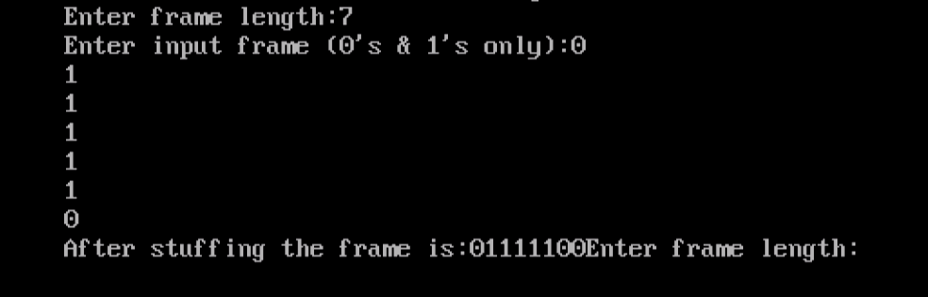

if(a[i]==1)
{
b[j]=a[i];
for(k=i+1;a[k]==1 && k<n && count<5;k++)
{
j++;
b[j]=a[k];
count++;
if(count==5)
{
j++;
b[j]=0;
}
i=k;
}}
else
{
b[j]=a[i];
}
i++;
j++;
}
printf("After stuffing the frame is:");
for(i=0;i<j;i++)
printf("%d",b[i]);
}

1. B) Implement character stuffing on given data

Algorithm:
Step 1: Initially give the user 2 choices, whether to character stuff or to directly exit, if wrong
choice is entered then prompt an invalid choice message.
Step 2: Intake from the user the number of characters which are to be character stuffed.
Step 3: Read the characters .
Step 4: Original data is displayed and the characters to be stuffed at the start and end of the frame are uploaded in the program.
Step 5: If DLE character is present then stuff DLE character before it.
Step 6: The characters DLESTX are inserted at the start and end of the data.
Step 7: The data along with the stuffed characters are displayed
Step 8: The original data is recovered and displayed on the receiving side
Step 9: Stop

Program :
#include<stdio.h>
#include<conio.h>
#include<stdlib.h>
void charc(void);
void main()
{
int
choice;
while(1)
{
printf("\n\n\n1.character stuffing");
printf("\n\n2.exit");
printf("\n\n\nenterchoice");
scanf("%d",&choice);
printf("%d",choice);
if(choice>2)
printf("\n\n invalid option ... please renter");
switch(choice)
{

case1:charc();
break;
case 2:_exit(0);
}
}
}
void charc(void)
{
clrscr();
char
c[50],d[50],t[50];
int i,m,j;
printf("enter the number of characters\n");
scanf("%d",&m);

printf("\n enter the characters\n");
for(i=0;i<m+1;i++)
{
scanf("%c",&c[i]);
}
printf("\n original data\n");
for(i=0;i<m+1;i++)
printf("%c",c[i]);d[0]='d';
d[1]='l';d[2]='e';
d[3]='s';d[4]='t';
d[5]='x';
for(i=0,j=6;i<m+1;i++,j++)
{
if((c[i]=='d'&&c[i+1]=='l'&& c[i+2]=='e'))
{
d[j]='d'; j++;
d[j]='l'; j++;
d[j]='e'; j++;
m=m+3;
}
d[j]=c[i];
}
m=m+6; m++;
d[m]='d'; m++;
d[m]='l'; m++;
d[m]='e'; m++;
d[m]='s'; m++;
d[m]='t'; m++;
d[m]='x';
m++;
printf("\n\n transmitted data: \n"); for(i=0;i<m;i++)
{
printf("%c",d[i]);
}
for(i=6,j=0;i<m-6;i++,j++)
{
if(d[i]=='d'&&d[i+1]=='l'&&d[i+2]=='e'&&d[i+3]=='d'&&d[i+4]=='l'&&d[i+5]=='e')
i=i+3;
t[j]=d[i];
}
printf("\n\nreceived data:");
for(i=0;i<j;i++)
{
printf("%c",t[i]);
}
}

Output 1: ( Character Stuffing)

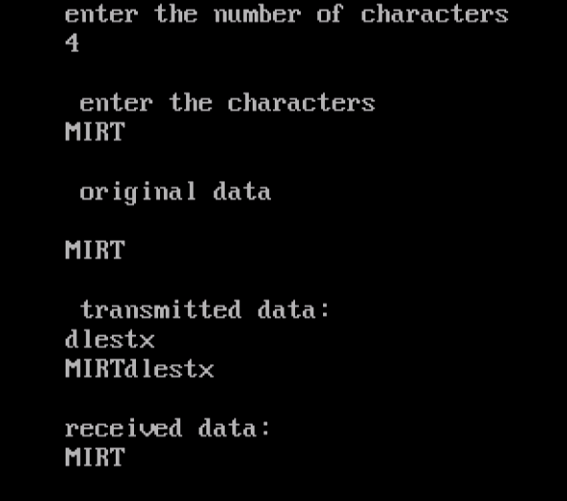

Output 2: (Character Stuffing)
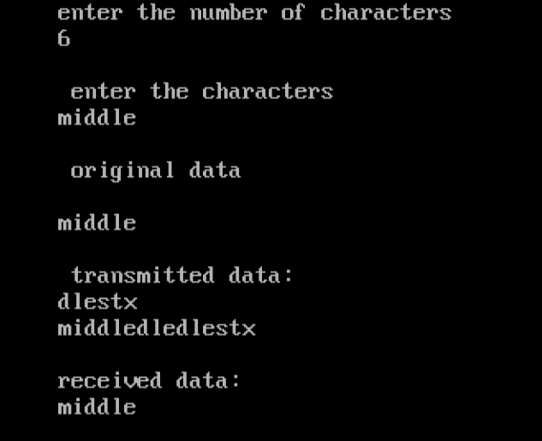

RESULT:
Thus the C Programs to implement the Data Link Layer Framing methods like i) Bit Stuffing ii) Character stuffing are executed successfully.

Exp No.: 2  Date : | IMPLEMENTATION OF ERROR DETECTION / CORRECTION TECHNIQUES  a) LRC, b) CRC, c) Hamming code
AIM: To write a C Program to implement Error detection and Correction using LRC, CRC and Hamming Techniques
SOFTWARE REQUIRED:
- C COMPILER
Longitudinal Redundancy Check (LRC) is also known as 2-D parity check. In this method, data is organised into tables of rows and columns. A block of bit is divided into table or matrix of rows and columns. In order to detect an error, a redundant bit is added to the whole block and this block is transmitted to receiver. The receiver uses this redundant row to detect error. After checking the data for errors, receiver accepts the data and discards the redundant row of bits.
PROGRAM TO IMPLEMENT LRC :
#include<stdio.h>
#include<conio.h>
void main()
{
int l1,bit[100],count=0,i,choice;
clrscr();
printf("Enter the length of data stream: ");
scanf("%d",&l1);
printf("\nEnter the data stream ");
for(i=0;i<=l1-1;i++)
{
scanf("%d",&bit[i]);
if(bit[i]==1)
count=count+1;
}
printf("Number of 1's are %d",count);
printf("\nEnter the choice to implement parity bit");
printf("\n1-Sender side\n2-Receiver side\n");
scanf("%d",&choice);
switch(choice)
{
case 1:
if(count%2==0)
bit[l1]=0;
else
bit[l1]=1;

printf("\nThe data stream after adding parity bit is\n");
for(i=0;i<=l1;i++)
printf("%d",bit[i]);
break;

case 2:
if(count%2==0)
printf("There is no error in the received data stream");
else
printf("There is error in the received data stream");
break;

default:
printf("Invalid choice");
break;
}
getch();
}

OUTPUT
Enter the length of data stream: 10
Enter the data stream 1 1 0 1 0 1 1 1 0 1
Number of 1's are 7
Enter the choice to implement parity bit
1-Sender side
2-Receiver side
1
The data stream after adding parity bit is
11010111011
Enter the length of data stream: 10
Enter the data stream 1 1 1 1 1 0 0 0 1 0
Number of 1's are 6
Enter the choice to implement parity bit
1-Sender side
2-Receiver side
2
There is no error in the received data stream

CRC (Cyclic Redundancy Check) CODE GENERATOR:
Algorithm
1. A string of n as is appended to the data unit. The length of predetermined divisor is n+ 1.
2. The newly formed data unit i.e. original data + string of n as are divided by the divisor using binary division and remainder is obtained. This remainder is called CRC.
3. Then the string of n 0’s appended to data unit is replaced by the CRC remainder (which is also
of n bit).
4. The data unit + CRC is then transmitted to receiver.
5. The receiver on receiving it divides data unit + CRC by the same divisor & checks the
remainder.
6. If the remainder of division is zero, receiver assumes that there is no error in data and it
accepts it.
7. If remainder is non-zero then there is an error in data and receiver rejects it.
PROGRAM:
#include<stdio.h>
#include<math.h>
#include<conio.h>
#include<string.h>
main()
{
int i,j,k,m,n,cl;
char a[10],b[100],c[100];
clrscr();
printf("\n ENTER POLYNOMIAL:");
scanf("%s",a);
printf("\n ENTER THE FRAME:");
scanf("%s",b);
m=strlen(a);
n=strlen(b);
for(i=0;i<m;i++) /* To eliminate first zeros in polynomial */
{
if(a[i]=='1')
{
m=m-i; break;
}
}
for(k=0;k<m;k++) /* To Adjust the polynomial */
a[k]=a[k+i];
cl=m+n-1;
for(i=0;i<n;i++) /* To copy the original frame to c[]*/
c[i]=b[i];
for(i=n;i<cl;i++) /* To add n-1 zeros at the end of frame */
c[i]='0';
c[i]='\0'; /*To make it as a string */
for(i=0;i<n;i++) /* To set polynomial remainder at end of c[]*/
if(c[i]=='1')
{
for(j=i,k=0;k<m;k++,j++)
if(a[k]==c[j])
c[j]='0';
else c[j]='1';
}
for(i=0;i<n;i++) /* To copy original data in c[] */
c[i]=b[i];
printf("\n THE MESSAGE IS: %s",c);
getch();
}

INPUT/OUTPUT:
ENTER POLYNANOMIAL:1011 ENTER THE FRAME:10011101
THE MESSAGE IS: 10011101011

ENTER POLYNANOMIAL:00101 ENTER THE FRAME:10101011
THE MESSAGE IS: 1010101101

CRC CHECKER:
PROGRAM:
#include<stdio.h>
#include<math.h>
#include<conio.h>
#include<string.h>
main()
{
int i,j,k,m,n,cl;
char a[10],c[100]; clrscr();
printf("\n ENTER POLYNANOMIAL:");
scanf("%s",a);
printf("\n ENTER THE CRC FRAME:");
scanf("%s",c); m=strlen(a);
cl=strlen(c);
for(i=0;i<m;i++) /* To eliminat first zeros in polynomial
*/
{
if(a[i]=='1')
{ m=m-i; break; }
}
for(k=0;k<m;k++) /* To Adjust the polynomial */
a[k]=a[k+i];
n=cl-m+1;
for(i=0;i<n;i++) /* To check polynomial remainder is zero or not */
if(c[i]=='1')
{
for(j=i,k=0;k<m;k++,j++) if(a[k]==c[j])
c[j]='0';
else c[j]='1';
}
for(i=0;i<cl;i++) /* To copy original data in c[] */
if(c[i]=='1')
{
printf("\n THERE IS SOME ERROR IN MESSAGE :");
break;
}
if(i==cl)
printf("\n MESSAGE IS CORRECT");
getch(); }

INPUT/OUTPUT :
ENTER POLYNANOMIAL: 1011
ENTER THE CRC FRAME: 10101011101
THERE IS SOME ERROR IN MESSAGE:

ENTER POLYNANOMIAL: 01011
ENTER THE CRC FRAME: 10011101011
MESSAGE IS CORRECT

2.C ) HAMMING CODE
Hamming code is used to detect and correct the error in the transmitted data. So, it is an error detection and correction code.
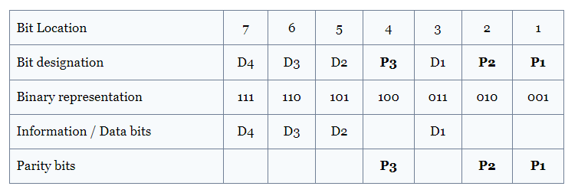
Where
P1 is Even Parity of Bit Locations 3,5,7,9
P2 is Even Parity of Bit Locations 3, 6, 7
P1 is Even Parity of Bit Locations 5, 6, 7
P1 is Even Parity of Bit Locations 8, 9

ALGORITHM:
1. Read the Frame Length of the data
2. Read the Data Bits
3. Find the Number of Redundant Bits
4. Compute the Parity Bits and the Codeword
5, Read the Received codeword and find the Error bit Position

PROGRAM:
#include <stdio.h>
#include <math.h>
int input[32];
int code[32];
int error_pos = 0;
int ham_calc(int,int);
void main()
{

int n,i,p_n = 0,c_l,j,k;
printf("Please enter the length of the Data Word: ");
scanf("%d",&n);
printf("Please enter the Data Word:\n");
for(i=0;i<n;i++)
{
scanf("%d",&input[i]);
}

i=0;
while(n>(int)pow(2,i)-(i+1))
{
p_n++;
i++;
}

c_l = p_n + n;

j=k=0;
for(i=0;i<c_l;i++)
{

if(i==((int)pow(2,k)-1))
{
code[i]=0;
k++;
}
else
{
code[i]=input[j];
j++;
}
}
for(i=0;i<p_n;i++)
{
int position = (int)pow(2,i);
int value = ham_calc(position,c_l);
code[position-1]=value;
}
printf("\nThe calculated Code Word is: ");
for(i=0;i<c_l;i++)
printf("%d",code[i]);
printf("\n");
printf("Please enter the received Code Word:\n");
for(i=0;i<c_l;i++)
scanf("%d",&code[i]);

//int error_pos = 0;
for(i=0;i<p_n;i++)
{
int position = (int)pow(2,i);
int value = ham_calc(position,c_l);
if(value != 0)
error_pos+=position;
}
if(error_pos == 1)
printf("The received Code Word is correct.\n");
else
printf("Error at bit position: %d\n",error_pos);
}
int ham_calc(int position,int c_l)
{
int count=0,i,j;
i=position-1;
while(i<c_l)
{
for(j=i;j<i+position;j++)
{
if(code[j] == 1)
count++;
}
i=i+2*position;
}
if(count%2 == 0)
return 0;
else
return 1;
}

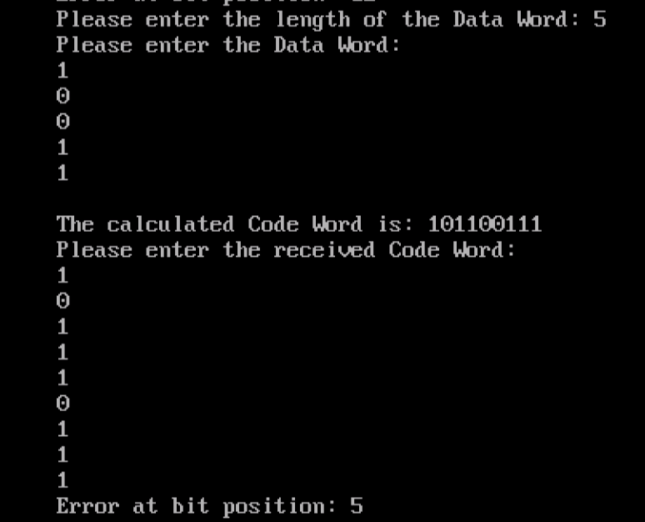

RESULT: Thus the Error detection and Correction using LRC, CRC and Hamming Techniques are implemented using C Program and executed successfully.

Exp No.: 3  Date : | IMPLEMENTATION OF  STOP AND WAIT, AND SLIDING WINDOW PROTOCOLS

AIM: To write a C Program to implement Stop and wait and Sliding Window Protocol
SOFTWARE REQUIRED:
- C COMPILER

STOP AND WAIT PROTOCOL
Stop-and-wait is the simplest kind of automatic repeat-request (ARQ) method. A stop and-wait ARQ sender sends one frame at a time. After sending each frame, the sender doesn't send any further frames until it receives an acknowledgement (ACK) signal. After receiving a good frame, the receiver sends an ACK. If the ACK does not reach the sender before a certain time, known as the timeout, the sender sends the same frame again.

PROGRAM FOR STOP AND WAIT PROTOCOL
#include <conio.h>
#include <dos.h>
#include <stdio.h>
#include <stdlib.h>
#define TIMEOUT 5
#define MAX_SEQ 1
#define TOT_PACKETS 8
#define inc(k) if(k<MAX_SEQ) k++; else k=0;
typedef struct
{
int data;
}packet;
typedef struct
{
int kind;
int seq;
int ack;
packet info;
int err;
}frame;
frame DATA;
typedef enum{frame_arrival,err,timeout,no_event} event_type;

void from_network_layer(packet *);
void to_network_layer(packet *);
void to_physical_layer(frame *);
void from_physical_layer(frame *);
void wait_for_event_sender(event_type *);
void wait_for_event_reciever(event_type *);
void reciever();
void sender();

int i=1; //Data to be sent by sender
char turn; //r , s
int DISCONNECT=0;
/*__________________________________________________________________________*/
void main()
{
clrscr();
randomize();
while(!DISCONNECT)
{
sender();
delay(400);
reciever();
}
getch();
}
/*__________________________________________________________________________*/
void sender()
{
static int frame_to_send=0;
static frame s;
packet buffer;
event_type event;
static int flag=0;

if(flag==0)
{
from_network_layer(&buffer);
s.info = buffer;
s.seq = frame_to_send;
printf("SENDER : Info = %d Seq No = %d ",s.info,s.seq);
turn = 'r';
to_physical_layer(&s);
flag = 1;
}
wait_for_event_sender(&event);
if(turn=='s')
{
if(event==frame_arrival)
{
from_network_layer(&buffer);
inc(frame_to_send);
s.info = buffer;
s.seq = frame_to_send;
printf("SENDER : Info = %d Seq No = %d ",s.info,s.seq);
turn = 'r';
to_physical_layer(&s);
}
if(event==timeout)
{
printf("SENDER : Resending Frame ");
turn = 'r';
to_physical_layer(&s);
}
}
}
/*__________________________________________________________________________*/
void reciever()
{
static int frame_expected=0;
frame r,s;
event_type event;

wait_for_event_reciever(&event);
if(turn=='r')
{
if(event==frame_arrival)
{
from_physical_layer(&r);
if(r.seq==frame_expected)
{
to_network_layer(&r.info);
inc(frame_expected);
}
else
printf("RECIEVER : Acknowledgement Resent\n");

turn = 's';
to_physical_layer(&s);
}
if(event==err)
{
printf("RECIEVER : Garbled Frame\n");
turn = 's'; //if frame not recieved
} //sender shold send it again
}
}
/*__________________________________________________________________________*/
void from_network_layer(packet *buffer)
{
(*buffer).data = i;
i++;
}
/*___________________________________________________________________________*/
void to_physical_layer(frame *s)
{ // 0 means error
s->err = random(4); //non zero means no error
DATA = *s; //probability of error = 1/4
}
/*___________________________________________________________________________*/
void to_network_layer(packet *buffer)
{
printf("RECIEVER :Packet %d recieved , Ack Sent\n",(*buffer).data);
if(i>TOT_PACKETS) //if all packets recieved then disconnect
{
DISCONNECT = 1;
printf("\nDISCONNECTED");
}
}
/*___________________________________________________________________________*/
void from_physical_layer(frame *buffer)
{
*buffer = DATA;
}
/*___________________________________________________________________________*/
void wait_for_event_sender(event_type * e)
{
static int timer=0;

if(turn=='s')
{
timer++;
if(timer==TIMEOUT)
{
*e = timeout;
printf("SENDER : Ack not recieved=> TIMEOUT\n");
timer = 0;
return;
}
if(DATA.err==0)
*e = err;
else
{
timer = 0;
*e = frame_arrival;
}
}
}
/*____________________________________________________________________________*/
void wait_for_event_reciever(event_type * e)
{
if(turn=='r')
{
if(DATA.err==0)
*e = err;
else
*e = frame_arrival;
}

}

OUTPUT:

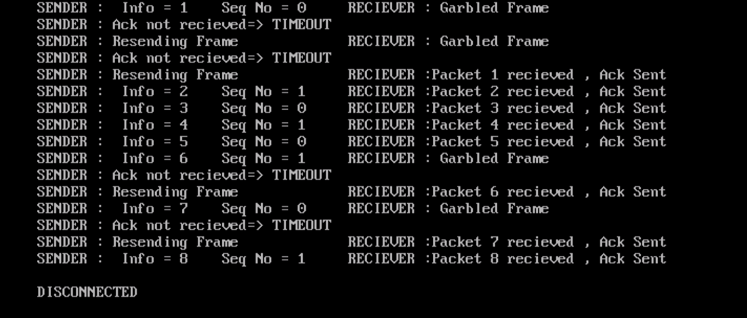
SLIDING WINDOW PROTOCOL:
In Sliding window protocol, both sender and receiver agrees on some window size. If window size=w then after sending w frames sender waits for the acknowledgement (ack) of the first frame. As soon as sender receives the acknowledgement of a frame, the window is replaced by the next frames to be transmitted by the sender. If receiver sends a collective or cumulative acknowledgement to sender then it understands that more than one frames are properly received, for eg:- if ack of frame 3 is received it understands that frame 1 and frame 2 are received properly.
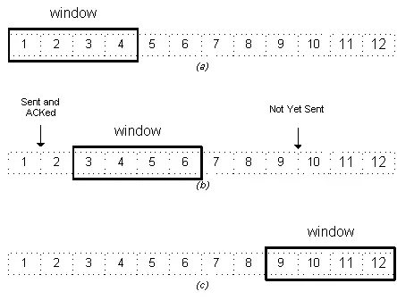
SLIDING WINDOW PROGRAM:

#include<stdio.h>

int main()
{
int w,i,f,frames[50];

printf("Enter window size: ");
scanf("%d",&w);

printf("\nEnter number of frames to transmit: ");
scanf("%d",&f);

printf("\nEnter %d frames: ",f);

for(i=1;i<=f;i++)
scanf("%d",&frames[i]);

printf("\nWith sliding window protocol the frames will be sent in the following manner (assuming no corruption of frames)\n\n");
printf("After sending %d frames at each stage sender waits for acknowledgement sent by the receiver\n\n",w);

for(i=1;i<=f;i++)
{
if(i%w==0)
{
printf("%d\n",frames[i]);
printf("Acknowledgement of above frames sent is received by sender\n\n");
}
else
printf("%d ",frames[i]);
}

if(f%w!=0)
printf("\nAcknowledgement of above frames sent is received by sender\n");

return 0;
}

OUTPUT:

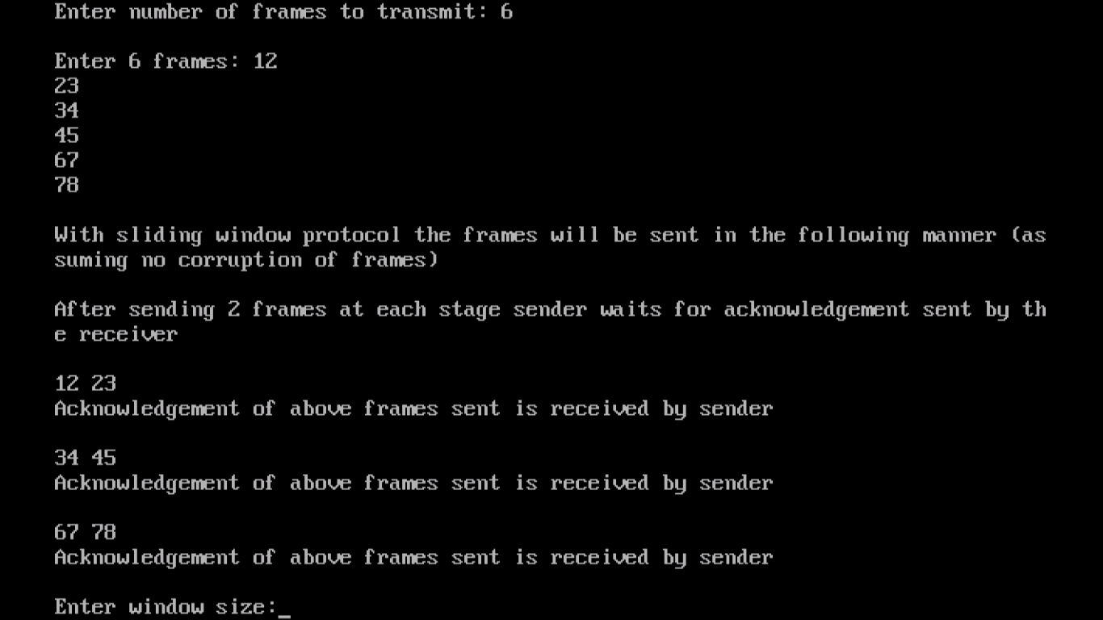

RESULT: Thus the implementation of Stop and Wait and Sliding Window Protocols are made using C Language and verified successfully.

Exp No.: 4  Date : | IMPLEMENTATION OF  GO BACK-N AND SELECTIVE REPEAT PROTOCOLS

AIM: To write a C Program to implement Go back-N and Selective Repeat Protocols
SOFTWARE REQUIRED:
- C COMPILER

Go Back- N PROTOCOL
Go-Back-N ARQ is an automatic repeat request (ARQ) protocol, in which the sender continues to send multiple frames before receiving the acknowledgment for the first frame. If the acknowledgment of a frame is not received within an agreed upon time period, all frames starting from that frame are retransmitted.

SELECTIVE REPEAT PROTOCOL:
Selective Repeat ARQ / Selective Reject ARQ is an Automatic Repeat-Request (ARQ) protocol used for communications. The source node transmits the frames continuously. If any of the frames are received with error, only those frames are requested for retransmission (with a negative acknowledgement). Here, only the erroneous or lost frames are retransmitted, while the good frames are received and buffered. If there is an error in frame 3, an acknowledgement for the frame 2 is sent and only Frame 3 is retransmitted.

PROGRAM FOR GO BACK N & SELECTIVE REPEAT PROTOCOLS:
#include<stdio.h>
#include<stdlib.h>
#include<math.h>
//include<unistd.h>
int n,r;
struct frame
{
char ack;
int data;
}frm[10];
int sender(void);
void recvack(void);
void resend(void);
void resend1(void);
void goback(void);
void selective(void);
int main()
{
int c;
do
{
printf("\n\n1.Selective repeat ARQ\n2.Goback ARQ\n3.exit");
printf("\nEnter your choice:");
scanf("%d",&c);
switch(c)
{
case 1:selective();
break;
case 2:goback();
break;
case 3:exit(0);
break;
}
}while(c>=4);
}
void goback()
{
sender();
recvack();
resend1();
printf("\n all packets sent successfully\n");
}
void selective()
{
sender();
recvack();
resend();
printf("\nAll packets sent successfully");
}
int sender()
{
int i;
printf("\nEnter the no. of packets to be sent:");
scanf("%d",&n);
for(i=1;i<=n;i++)
{
printf("\nEnter data for packets[%d]",i);
scanf("%d",&frm[i].data);
frm[i].ack='y';
}
return 0;
}
void recvack()
{
int i;
rand();
r=rand()%n;
frm[r].ack='n';
for(i=1;i<=n;i++)
{
if(frm[i].ack=='n')
printf("\nThe packet number %d is not received\n",r);
}
}
void resend() //SELECTIVE REPEAT
{
printf("\nresending packet %d",r);
sleep(2);
frm[r].ack='y';
printf("\nThe received packet is %d",frm[r].data);
}
void resend1() //GO BACK N
{
int i;
printf("\n resending from packet %d",r);
for(i=r;i<=n;i++)
{
sleep(2);
frm[i].ack='y';
printf("\nReceived data of packet %d is %d",i,frm[i].data);
}
}

OUTPUT: ( GO BACK N)
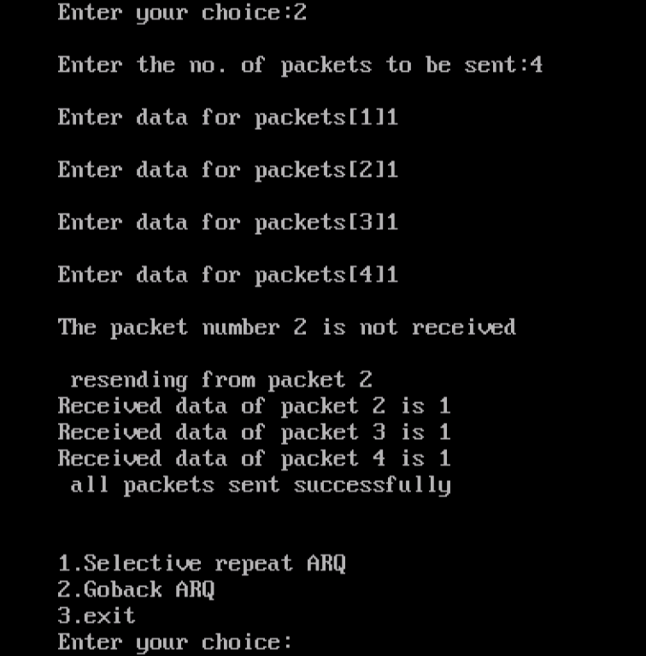

OUTPUT (SELECTIVE REPEAT):

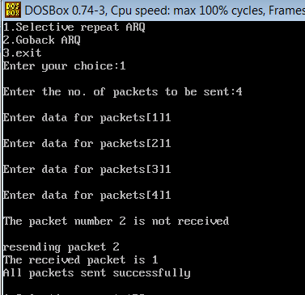

RESULT: Thus the implementation of Go Back N and Selective Repeat Protocols are made using C Language and verified successfully.

Exp No.: 5  Date : | IMPLEMENTATION OF  DATA ENCRYPTION AND DECRYPTION USING RSA (RIVEST, SHAMIR AND ADLEMAN) ALGORITHM.

AIM: To implement Data Encryption and Decryption using RSA Algorithm

RSA ALGORITHM:
RSA (RIVEST, SHAMIR AND ADLEMAN) algorithm is an asymmetric cryptography algorithm. Asymmetric actually means that it works on two different keys i.e. Public Key and Private Key. As the name describes that the Public Key is given to everyone and the Private key is kept private.
KEY GENERATION:
- Choose two large prime numbers (p and q)
- Calculate n = p*q and r = (p-1)(q-1)
- Choose two numbers e,d such that ed = 1mod r
Public Key = { e,n} PRIVATE KEY={d,n}
EXAMPLE:
Let p= 17 and q=11
n= pxq= 187
r= (p-1)(q-1) = 16 x 10 = 160

Candidates of 1 mod r are as follows: 161, 321, 481 etc..
Factors of 161: 7 x 23
e=7
d=23
Public Key = {e,n} =>{7,187}
Private Key={d,n}=>{23,187}

Cipher Text C = M^e mod n
Plain Text M= C^d mod n

PROCEDURE:
1. Create an input file (inp.txt) with the message to be encrypted
2. Create an output file (out.txt) where the cipher text is to be stored
3. Run the encryption program with the Public key values {e,n}
4. Create another output file (outd.txt) where the decrypted output is to be stored
5. Run the Decryption program with the Private key values {d,n}
6. Check the messages in the inp.txt and the decrypted output in the file outd.txt

RSA ENCRYPTION PROGRAM:
#include<stdio.h>
main()
{
int k,b,bin[20];
int i;
long int c,m,e,d,n;
char ch;
char in_file[20],out_file[20];
FILE *in,*out;
clrscr();
printf("\n Enter any input text file name : ");
gets(in_file);
printf("\n Enter file name to store enc output : ");
gets(out_file);
in = fopen(in_file,"r");
out = fopen(out_file,"w");
printf("\n Enter values of e and n : ");
scanf("%ld%ld",&e,&n);
i=-1;
b=e;
while(b>0)
{
bin[++i] = b%2;
b=b/2;
}
k=i;
do
{
m = fgetc(in);
d = 1;
for( i=k; i>=0; i--)
{
d = (d*d) % n;
if (bin[i] == 1)
d = (d*m) % n;
}
fputc(d,out);
}
while(!feof(in));
printf("\n File is encrypted successfully. ... ");
getch();
return 0;
}

RSA ENCRYPTION:

INPUT:
DATA IN THE FILE : inp.txt

ELCOMM ASSOCIATION-ECESSMCE

Enter any input text file name : inp.txt

Enter file name to store enc output : out.txt

Enter values of e and n : 7 187

OUTPUT
File is encrypted successfully. ...

ENCRYPTED OUTPUT IN THE FILE : out.txt

V C‹yyLŽ‹C=Ž2=‹8zVCVyCVÿ

RSA DECRYPTION PROGRAM:
#include<stdio.h>
main()
{
int k,b,bin[20];
int i;
long int c,m,e,d,n;
char ch;
char in_file[20],out_file[20];
FILE *in,*out;
clrscr();
printf("\n Enter any ciphertext file name : ");
gets(in_file);
printf("\n Enter file name to store decrypted output : ");
gets(out_file);
in = fopen(in_file,"r");
out = fopen(out_file,"w");
printf("\n Enter values of d and n : ");
scanf("%ld%ld",&e,&n);
i=-1;
b=e;
while(b>0)
{
bin[++i] = b%2;
b=b/2;
}
k=i;
do
{
m = fgetc(in);
d = 1;
for( i=k; i>=0; i--)
{
d = (d*d) % n;
if (bin[i] == 1)
d = (d*m) % n;
}
fputc(d,out);
}
while(!feof(in));
printf("\n File is decrypted successfully. ... ");
getch();
return 0;
}

RSA DECRYPTION:

INPUT:
Cipher Text in the file:out.txt (Obtained by Running the RSA Encryption Program)
V C‹yyLŽ‹C=Ž2=‹8zVCVyCVÿ

Enter any cipher text file name : out.txt

Enter file name to store decrypted output :outd.txt

Enter values of d and n : 23 187

OUTPUT:
ELCOMM ASSOCIATION-ECESSMCEUÿ

RESULT: Thus the C programs to implement Data Encryption and Decryption using RSA Algorithm is successfully verified.

Exp No.: 6  Date : | IMPLEMENTATION OF DISTANCE VECTOR ROUTING ALGORITHM (ROUTING INFORMATION PROTOCOL) (BELLMAN-FORD).

AIM: To implement Distance vector Routing Algorithm using Bellman Ford Equation

INTRODUCTION:

Routing is the process of path selection in any network. In Distance Vector Routing, Each router periodically shares a list of networks it can reach and the distance to that network (Cost) to its neighbors.
The heart of distance-vector routing is the famous Bellman-Ford equation.
This equation is used to find the least cost (shortest distance) between a source node, x, and a destination node, y, through some intermediary nodes (a, b, c, . . .) when the costs between the source and the intermediary nodes and the least costs between the intermediary nodes and the destination are given.
PROCEDURE:
1
2
3
4
5
6
2
5
5
3
4
4
2

Step 1: The Given Network is represented as table shown below with 0 as cost for the same Node and 9 ( Representing an ∞ ) for a destination without a direct connection. For Example Node 1-> Node 1 is represented as 0 and Node 1 -> Nodes (5,6) are represented as 9 as there is no direct path in the network from Node 1 to 5, 6.

 | Destination
Source | Node 1 | Node 2 | Node 3 | Node 4 | Node 5 | Node 6
Node 1 | 0 | 2 | 3 | 3 | 9 | 9
Node 2 | 2 | 0 | 5 | 9 | 4 | 9
Node 3 | 9 | 5 | 0 | 9 | 9 | 4
Node 4 | 3 | 9 | 9 | 0 | 5 | 9
Node 5 | 9 | 4 | 9 | 5 | 0 | 2
Node 6 | 9 | 9 | 4 | 9 | 2 | 0

Step 2: The above table is Is represented as input to the program as
0 2 9 3 9 9
2 0 5 9 4 9
9 5 0 9 9 4
3 9 9 0 5 9
9 4 9 5 0 2
9 9 4 9 2 0
Step 3: The Least cost distances calculated by the program is received as output
Step 4: To update the network for a change in the least cost distances, the cost of a particular node is entered and the whole least cost distances for the whole network is verified from the updated output.

DISTANCE VECTOR ROUTING PROGRAM:
#include<stdio.h>
#include<conio.h>
int dist[50][50],temp[50][50],n,i,j,k,x;
void dvr();
int main()
{
clrscr();
printf("\nEnter the number of nodes : ");
scanf("%d",&n);
printf("\nEnter the distance matrix :\n");
for(i=0;i<n;i++)
{
for(j=0;j<n;j++)
{
scanf("%d",&dist[i][j]);
dist[i][i]=0;
temp[i][j]=j;
}
printf("\n");
}
dvr();
printf("enter value of i &j:");
scanf("%d",&i);
scanf("%d",&j);
printf("enter the new cost");
scanf("%d",&x);
dist[i][j]=x;
printf("After update\n\n");
dvr();
return 0;
}
void dvr()
{
for (i = 0; i < n; i++)
for (j = 0; j < n; j++)
for (k = 0; k < n; k++)
if (dist[i][k] + dist[k][j] < dist[i][j])
{
dist[i][j] = dist[i][k] + dist[k][j];
temp[i][j] = k;
}
for(i=0;i<n;i++)
{ printf("\n\nState value for router %d is \n",i+1);
for(j=0;j<n;j++)
printf("\t\nnode %d via %d Distance%d",j+1,temp[i][j]+1,dist[i][j]);
} printf("\n\n");
getch();
}

OUTPUT:

Enter the number of nodes : 6
Enter the distance matrix :
0 2 9 3 9 9
2 0 5 9 4 9
9 5 0 9 9 4
3 9 9 0 5 9
9 4 9 5 0 2
9 9 4 9 2 0
State value for router 1 is

node 1 via 1 Distance0
node 2 via 2 Distance2
node 3 via 2 Distance7
node 4 via 4 Distance3
node 5 via 2 Distance6
node 6 via 5 Distance8

State value for router 2 is

node 1 via 1 Distance2
node 2 via 2 Distance0
node 3 via 3 Distance5
node 4 via 1 Distance5
node 5 via 5 Distance4
node 6 via 5 Distance6

State value for router 3 is

node 1 via 2 Distance7
node 2 via 2 Distance5
node 3 via 3 Distance0
node 4 via 4 Distance9
node 5 via 6 Distance6
node 6 via 6 Distance4

State value for router 4 is

node 1 via 1 Distance3
node 2 via 1 Distance5
node 3 via 3 Distance9
node 4 via 4 Distance0
node 5 via 5 Distance5
node 6 via 5 Distance7

State value for router 5 is

node 1 via 2 Distance6
node 2 via 2 Distance4
node 3 via 6 Distance6
node 4 via 4 Distance5
node 5 via 5 Distance0
node 6 via 6 Distance2

State value for router 6 is

node 1 via 5 Distance8
node 2 via 5 Distance6
node 3 via 3 Distance4
node 4 via 5 Distance7
node 5 via 5 Distance2
node 6 via 6 Distance0

enter value of i &j:4 3
enter the new cost2

After update

State value for router 1 is

node 1 via 1 Distance0
node 2 via 2 Distance2
node 3 via 2 Distance7
node 4 via 4 Distance3
node 5 via 2 Distance6
node 6 via 5 Distance8

State value for router 2 is

node 1 via 1 Distance2
node 2 via 2 Distance0
node 3 via 3 Distance5
node 4 via 1 Distance5
node 5 via 5 Distance4
node 6 via 5 Distance6

State value for router 3 is

node 1 via 2 Distance7
node 2 via 2 Distance5
node 3 via 3 Distance0
node 4 via 5 Distance8
node 5 via 6 Distance6
node 6 via 6 Distance4

State value for router 4 is

node 1 via 1 Distance3
node 2 via 1 Distance5
node 3 via 3 Distance9
node 4 via 4 Distance0
node 5 via 5 Distance5
node 6 via 5 Distance7

State value for router 5 is

node 1 via 4 Distance5
node 2 via 2 Distance4
node 3 via 6 Distance6
node 4 via 4 Distance2
node 5 via 5 Distance0
node 6 via 6 Distance2

State value for router 6 is

node 1 via 5 Distance7
node 2 via 5 Distance6
node 3 via 3 Distance4
node 4 via 5 Distance4
node 5 via 5 Distance2
node 6 via 6 Distance0

RESULT: Thus the C Program to implement Distance Vector Routing using Bellman Ford equation is implemented and verified successfully.

Exp No.: 7  Date : | DATA ENCRYPTION AND DECRYPTION USING DATA ENCRYPTION STANDARD ALGORITHM.

AIM: To implement DES (Data Encryption Standard ) Algorithm in C Language.

DATA ENCRYTION STANDARD (DES):

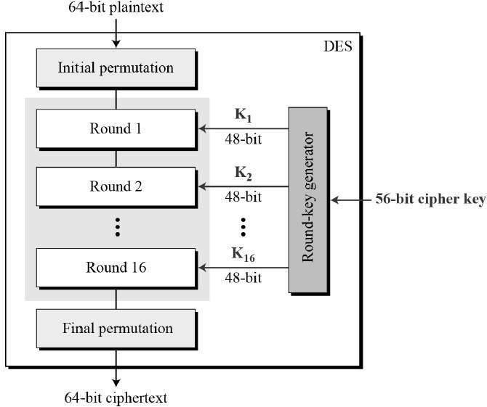
The DES Algorithm is a block cipher that uses symmetric keys to convert 64-bit plaintext blocks into 48-bit ciphertext blocks.
DES uses 16 Round Block Cipher.
The block size is 64-bit. Though, key length is 64-bit, DES has an effective key length of 56 bits, since 8 of the 64 bits of the key are not used by the encryption algorithm (function as Parity check bits only).

Simple DES:
The S-DES encryption algorithm takes an 8-bit block of plaintext (example: 10111101) and a 10-bit key as input and produces an 8-bit block of ciphertext as output.
The input to the algorithm is an 8-bit block of plaintext, which we first permute using the IP
function:
This retains all 8 bits of the plaintext but mixes them up. At the end of the algorithm, the inverse
permutation is used:

We can easily verify that, IP–1(IP(X)) = X.

PROGRAM:
#include <stdio.h>
#include <string.h>
#include <stdlib.h>

// Global variables

char output[9]; // ciphertext
char key_tmp[11]; // used as intermediate
char k1[9]; // subkey k1
char k2[9]; // subkey k2
char l[5];
char r[5];
char binary_tmp[3];
char s0_box[4][4];
char s1_box[4][4];
// --------------------------------------------------
// -- Constants used for Permutation and Switching --
// --------------------------------------------------
const int IP[8] =
{
1, 5, 2, 0, 3, 7, 4, 6};
const int IPI[8] =
{
3, 0, 2, 4, 6, 1, 7, 5
};
const int EP[8] =
{
3, 0, 1, 2, 1, 2, 3, 0};
const int P4[4] =
{
1, 3, 2, 0};

const int P10[11] =
{
2, 4, 1, 6, 3, 9, 0, 8, 7, 5};
const int P8[8] =
{
5, 2, 6, 3, 7, 4, 9, 8};

const int SW[8] =
{
4, 5, 6, 7, 0, 1, 2, 3};
// --- Encryption Functions ---//

void initial_permutation(char *input)
{
int i;
for (i = 0; i < 8; i++) output[i] = input[IP[i]];
output[8] = '\0';
}
void initial_permutation_inverse(char *input)
{
char output_final[9];
int i;
for (i = 0; i < 8; i++) output_final[i] = input[IPI[i]];
output_final[8] = '\0';
strcpy(output, output_final);
}
void switch_halves(char *input)
{
char out_tmp_switched[9];
int i;
for (i = 0; i < 8; i++) out_tmp_switched[i] = input[SW[i]];
out_tmp_switched[8] = '\0';
strcpy(output, out_tmp_switched);
}
void expansion_permutation(char *input)
{
int i;
for (i = 0; i < 8; i++) output[i] = input[EP[i]];
output[8] = '\0';
}
void p4_permutation(char *input)
{
char F_output[5];
int i;
for (i = 0; i < 4; i++) F_output[i] = input[P4[i]];
F_output[4] = '\0';
strcpy(output, F_output);
}
/* This function divides a 8-bit input into l (left) and r (right) with
4 bits each. */
void divide_block(char *output)
{
int i, j;
for (i = 0; i < 4; i++) {
l[i] = output[i];
}
l[i] = '\0';
for (j = 0; j < 4; j++) {
r[j] = output[i];
i++;
}
r[j] = '\0';
int convert_to_decimal(char *str)
{
if(strlen(str)!=2)
return -1;
if (strcmp(str,"00")==0)
return 0;
if (strcmp(str,"01")==0)
return 1;
if (strcmp(str,"10")==0)
return 2;
if (strcmp(str,"11")==0)
return 3;
return -1;
}
void convert_to_binary(int num, char *binary)
{
if(num == 0)
strcpy(binary,"00");
if(num == 1)
strcpy(binary,"01");
if(num == 2)
strcpy(binary,"10");
if(num == 3)
strcpy(binary,"11");
}
void xor(char *str1, char *str2)
{
unsigned long int i;
if (strlen(str1) != strlen(str2)) {
printf("Error: xor operation does not support different string lengths.\n");
exit(0);
}
for (i = 0; i < strlen(str1); i++) {
if (str1[i] == str2[i]) {
output[i] = '0';
}
else output[i] = '1';
}
output[i] = '\0';
}
void s0_items()
{
int i, j, k = 0;
int item[16] = {1, 0, 3, 2,
3, 2, 1, 0,
0, 2, 1, 3,
3, 1, 3, 2};
for (i = 0; i < 4; i++) {
for (j = 0; j < 4; j++) {
s0_box[i][j] = item[k];
k++;
}
}
}
void s1_items()
{
int i, j, k = 0;
int item[16] = {0, 1, 2, 3,
2, 0, 1, 3,
3, 0, 1, 0,
2, 1, 0, 3};
for (i = 0; i < 4; i++) {
for (j = 0; j < 4; j++) {
s1_box[i][j] = item[k];
k++;
}
}
}
/* Calculates the output for given sbox (0 or 1), returning a decimal number. */
int sbox_s(char *output, int i)
{
char tmp[3];
int row;
int column;
int s0;
int s1;
if (i == 0) {
//sbox_s0
tmp[0] = output[0];
tmp[1] = output[3];
tmp[2] = '\0';
row = convert_to_decimal(tmp);
tmp[0] = output[1];
tmp[1] = output[2];
tmp[2] = '\0';
column = convert_to_decimal(tmp);
s0_items();
s0 = s0_box[row][column];
return s0;
} else if (i == 1) {
//sbox_s1
tmp[0] = output[4];
tmp[1] = output[7];
tmp[2] = '\0';
row = convert_to_decimal(tmp);
tmp[0] = output[5];
tmp[1] = output[6];
tmp[2] = '\0';
column = convert_to_decimal(tmp);
s1_items();
s1 = s1_box[row][column];
return s1;
} else return -1;
}
/* This mapping is an intermediate process between the input and subkey passed
to the fk function */
void F_mapping(char *output, char *subkey)
{
char binary[3];
int s0;
int s1;
char output_sbox[5];
divide_block(output);
expansion_permutation(r);
xor(output, subkey);
s0 = sbox_s(output, 0);
convert_to_binary(s0, binary);
strcpy(output_sbox, binary);
s1 = sbox_s(output, 1);
convert_to_binary(s1, binary);
strcat(output_sbox, binary);
p4_permutation(output_sbox);
}
void fk(char *output, char *subkey)
{
F_mapping(output, subkey);
xor(l, output);
strcat(output, r);
}
// ------------------------------------------------
// --- Keys Generation Functions ---
// ------------------------------------------------
void p10_key_permutation(char *key)
{
int i;
for (i = 0; i < 10; i++) key_tmp[i] = key[P10[i]];
key_tmp[10] = '\0';
}
void circular_left_shift(char *key_tmp)
{
char temp = key_tmp[0];
int i;
for (i = 0; i < 5; i++) {
key_tmp[i] = key_tmp[i+1];
}
key_tmp[4] = temp;
temp = key_tmp[5];
for (i = 5 ; i < 10; i++) {
key_tmp[i] = key_tmp[i+1];
}
key_tmp[9] = temp;
}
void p8_key_permutation(char *key_tmp, int k)
{
int i;
if (k == 1) {
for (i = 0; i < 8; i++) k1[i] = key_tmp[P8[i]];
k1[8] = '\0';
}
else if(k == 2) {
for (i = 0; i < 8; i++) k2[i] = key_tmp[P8[i]];
k2[8] = '\0';
} else return;
}
void keys_generation(char *key)
{
// generating k1
p10_key_permutation(key);
circular_left_shift(key_tmp);
p8_key_permutation(key_tmp, 1);
// generating k2
circular_left_shift(key_tmp);
circular_left_shift(key_tmp); // repeated
p8_key_permutation(key_tmp, 2);
}
// ------------------------------------------------
// --- Encrypt Function ---
// ------------------------------------------------
void encrypt(char *input, char *key)
{
initial_permutation(input);
fk(output, k1);
switch_halves(output);
fk(output, k2);
initial_permutation_inverse(output);
}
// ------------------------------------------------
// --- Main Function ---
// ------------------------------------------------
int main(int argc, char const *argv[])
{
char input[9];
char key[11];
int opt;
do {
printf("\nPlaintext (8-bit): ");
scanf("%s", input);
} while (strlen(input) != 8);

do {
printf("Key (10-bit): ");
scanf("%s", key);
} while (strlen(key) != 10);
keys_generation(key);
encrypt(input, key);
printf("Ciphertext (8-bit): %s\n", output);
printf("\n");
return 0;
}

DES OUTPUT :

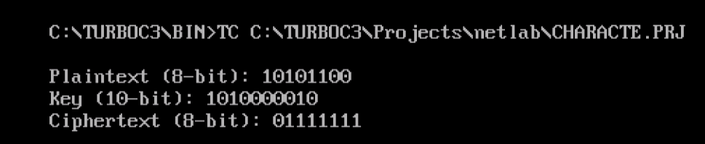

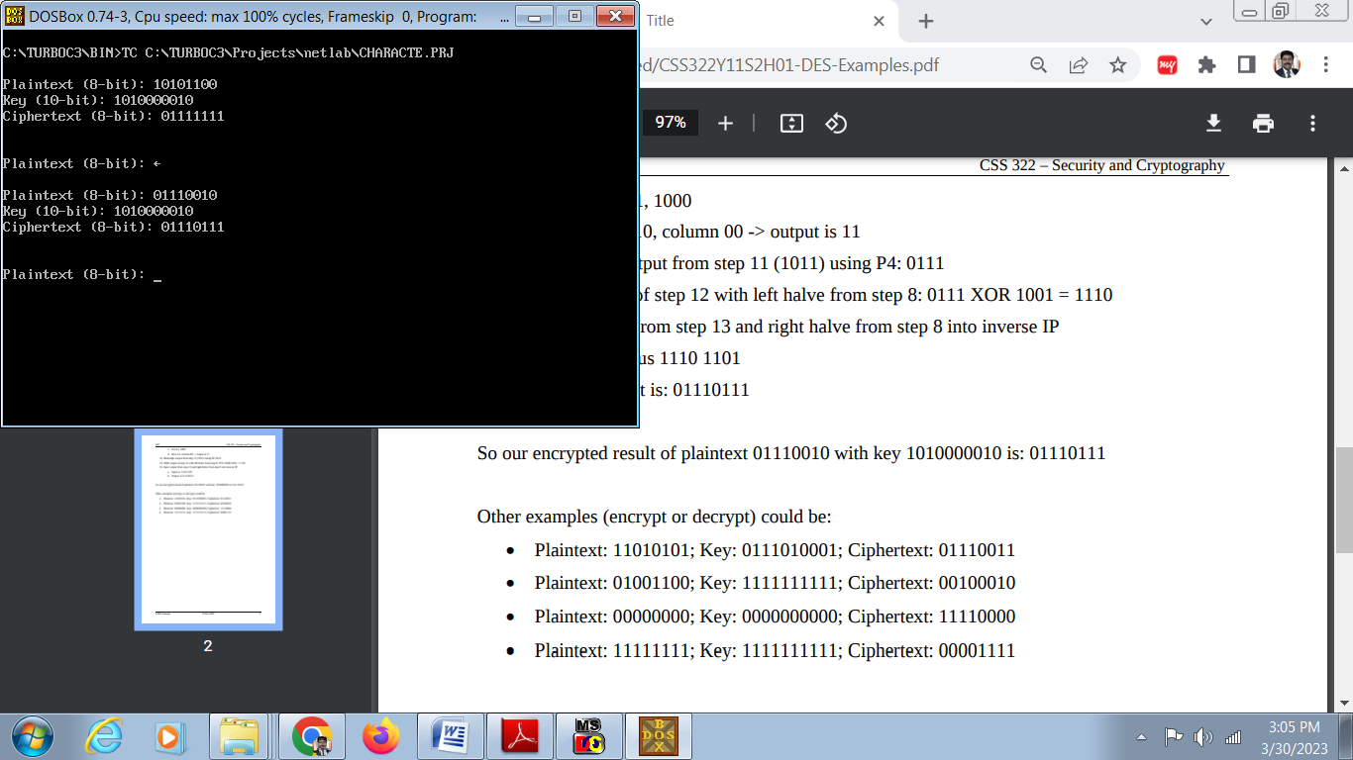

RESULT: Thus the Data Encryption Standard (DES) Algorithm is implemented in C and verified successfully.

Exp No.: 8  Date : | IMPLEMENTATION OF LINK STATE ROUTING ALGORITHM (OPEN SHORTEST PATH FIRST) WITH 5 NODES (DIJKSTRA'S).

Aim:
To write a C Program to implement Link State Routing (Open Shortest Path First) using Dijkstra's Algorithm.

LINK STATE ROUTING:
Link state routing is a technique in which each router shares the knowledge of its neighborhood with every other router in the internetwork. Each router sends the information to every other router on the internetwork except its neighbors. This process is known as Flooding.
Each node uses Dijkstra's algorithm on the graph to calculate the optimal routes to all nodes.
The collection of states for all links is called the link-state database (LSDB)
GIVEN NETWORK:
1
2
3
4
5
6
2
5
5
3
4
4
2

Dijkstra Algorithm
1. The node chooses itself as the root of the tree, creating a tree with a single node, and sets the total cost of each node based on the information in the LSDB.
2. The node selects one node, among all nodes not in the tree, which is closest to the root, and adds this to the tree. After this node is added to the tree, the cost of all other nodes not in the tree needs to be updated because the paths may have been changed.
3. The node repeats step 2 until all nodes are added to the tree.

PROCEDURE:
1. Start
2. Calculate the Adjacency Matrix for the Given Network
3. Run the Program
4. Input the Number of Nodes in the Given Network
5. Enter the Adjacency matrix (If there is no direct path, the distance is given as 9)
6. Enter the Destination Node
7. The Distance and Paths to the Destination Node in the output is verified.

PROGRAM:
#include<stdio.h>
#include<conio.h>
#include<string.h>
#include<math.h>
main()
{
int u,v,num,i,j,l,k,s[10],min,cost[10][10],dist[10],path[10],n;
clrscr();
printf("\n ENTER THE TOTAL NO. OF NODES:");
scanf("%d",&n);
printf("\n ENTER ADJECENCY MATRIX:\n");
for(i=1;i<=n;i++)
{
for(j=1;j<=n;j++)
scanf("%d",&cost[i][j]);
}
for(i=1;i<=n;i++)
for(j=1;j<=n;j++)
if(i==j) cost[i][j]=0;
else if(cost[i][j]==-1)
cost[i][j]=30000;
printf("\nENTER THE DESTINATION NODE NUMBER:");
scanf("%d",&v); clrscr();
for(i=1;i<=n;i++)
{
s[i]=0;
path[i]=v; dist[i]=cost[v][i];
}
dist[v]=0;
for(num=2;num<=n;num++)
{
min=30000; u=0;
for(i=1;i<=n;i++)
{
if(s[i]!=1) if(min>dist[i])
{
u=i; min=dist[i];
}
}
s[u]=1;
for(i=1;i<=n;i++)
{ if(s[i]!=1)
if(dist[i]>(min+cost[u][i]))
{
dist[i]=min+cost[u][i];
path[i]=u;
}
}
}
printf("\n");
printf("\nPATH MATRIX:\n");
printf("\nDISTANCE NODE PATH\n");
for(i=1;i<=n;i++)
{ printf("\n %d",dist[i]);
printf(" %d ",i);
j=i;
do
{
printf(" --> %d ",path[j]);
u=path[j];
j=u;
}while(u!=v);
}
getch();
return 0;
}

INPUT:

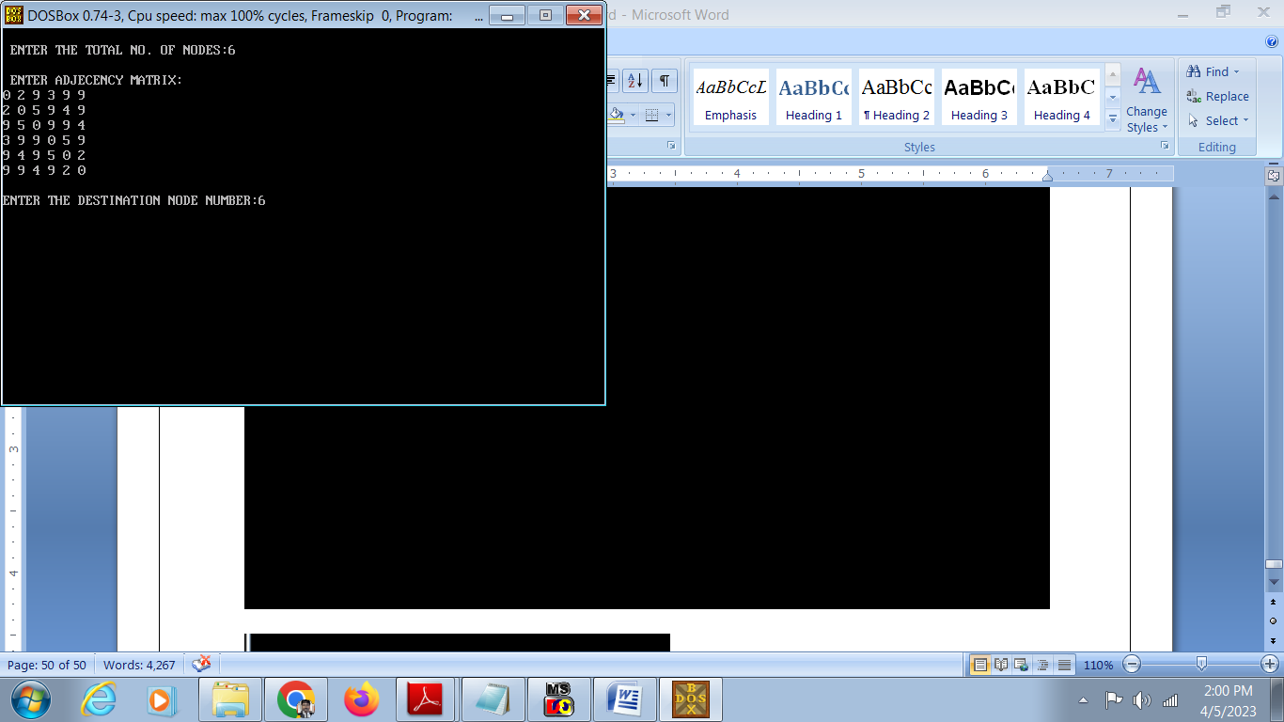

OUTPUT:

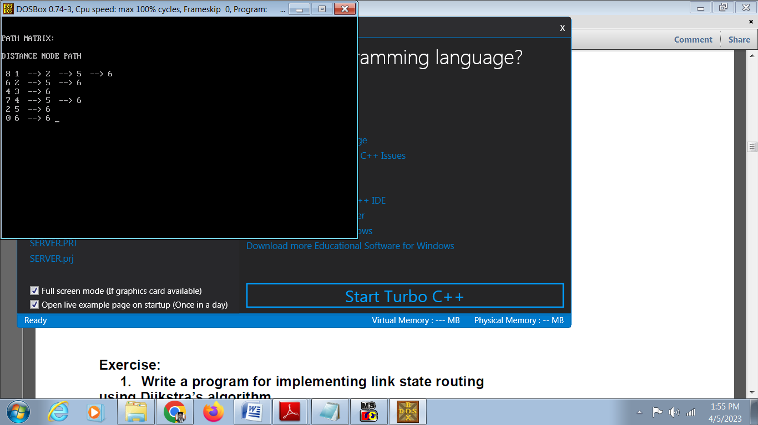

RESULT: Thus the Program to implement Link State Routing using Shortest Path Algorithm is verified successfully.

Exp No.: 9  Date : | IMPLEMENTATION CLIENT SERVER MODEL USING FTP PROTOCOL

AIM:
To write a program to implement Client Server Model using FTP protocol

SOFTWARE REQUIRED:
1. Ubuntu Platform
2. GCC C Compiler
ALGORITHM:
SERVER:
STEP 1: Start
STEP 2: Declare the variables for the socket
STEP 3: Specify the family, protocol, IP address and port number
STEP 4: Create a socket using socket() function
STEP 5: Bind the IP address and Port number
STEP 6: Listen and accept the client’s request for the connection
STEP 7: Establish the connection with the client
STEP 8: Close the socket
STEP 9: Stop
CLIENT:
STEP 1: Start
STEP 2: Declare the variables for the socket
STEP 3: Specify the family, protocol, IP address and port number
STEP 4: Create a socket using socket() function
STEP 5: Call the connect() function
STEP 6: Close the socket
STEP 7: Stop

FTP SERVER PROGRAM:
#include<stdio.h>
#include<arpa/inet.h>
#include<sys/types.h>
#include<sys/socket.h>
#include<netinet/in.h>
#include<netdb.h>
#include<stdlib.h>
#include<string.h>
#include<unistd.h>
#define SERV_TCP_PORT 5035
#define MAX 60
int i, j, tem;
char buff[4096], t;
FILE *f1;
int main(int afg, char *argv)
{
int sockfd, newsockfd, clength;
struct sockaddr_in serv_addr,cli_addr;
char t[MAX], str[MAX];
strcpy(t,"exit");
sockfd=socket(AF_INET, SOCK_STREAM,0);
serv_addr.sin_family=AF_INET;
serv_addr.sin_addr.s_addr=INADDR_ANY;
serv_addr.sin_port=htons(SERV_TCP_PORT);
printf("\nBinded");
bind(sockfd,(struct sockaddr*)&serv_addr, sizeof(serv_addr));
printf("\nListening...");
listen(sockfd, 5);
clength=sizeof(cli_addr);
newsockfd=accept(sockfd,(struct sockaddr*) &cli_addr,&clength);
close(sockfd);
read(newsockfd, &str, MAX);
printf("\nClient message\n File Name : %s\n", str);
f1=fopen(str, "r");
while(fgets(buff, 4096, f1)!=NULL)
{
write(newsockfd, buff,MAX);
printf("\n");
}
fclose(f1);
printf("\nFile Transferred\n");
return 0;
}

FTP CLIENT PROGRAM:
#include<stdio.h>
#include<sys/types.h>
#include<sys/socket.h>
#include<netinet/in.h>
#include<netdb.h>
#include<stdlib.h>
#include<string.h>
#include<unistd.h>
#define SERV_TCP_PORT 5035
#define MAX 60
int main(int arg,char*argv[])
{
int sockfd,n;
struct sockaddr_in serv_addr;
struct hostent*server;
char send[MAX],recvline[MAX],s[MAX],name[MAX];
sockfd=socket(AF_INET,SOCK_STREAM,0);
serv_addr.sin_family=AF_INET;
serv_addr.sin_addr.s_addr=inet_addr("127.0.0.1");
serv_addr.sin_port=htons(SERV_TCP_PORT);
connect(sockfd,(struct sockaddr*)&serv_addr,sizeof(serv_addr));
printf("\nEnter the source file name : \n");
scanf("%s",send);
write(sockfd,send,MAX);
while((n=read(sockfd,recvline,MAX))!=0)
{
printf("%s",recvline);
}
close(sockfd);
return 0;
}

INPUT & OUTPUT:
A terminal window is opened and First the server Program is compiled and Run as shown below

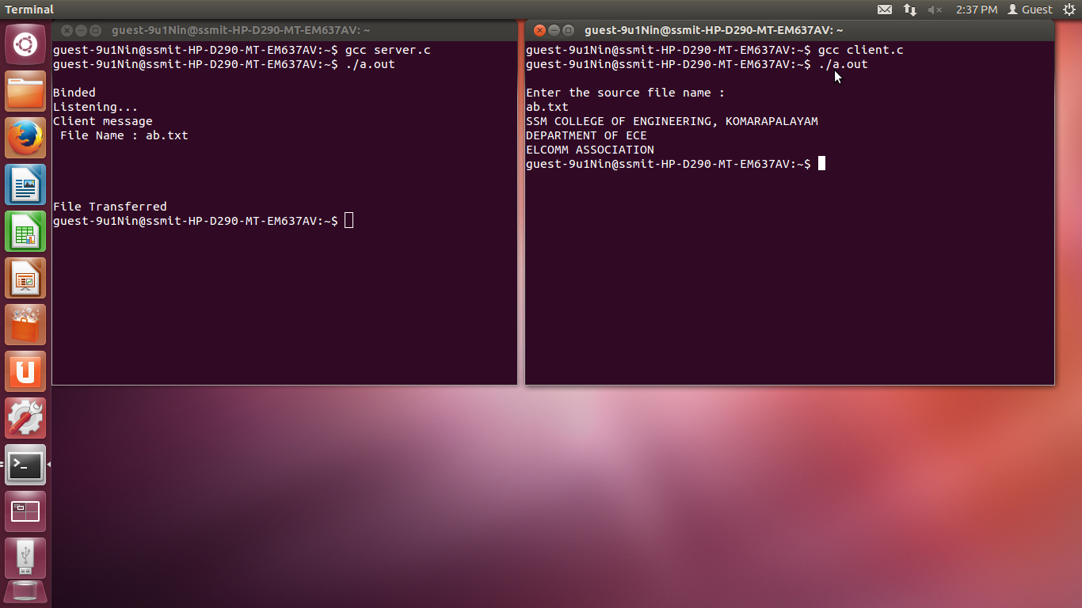

A new terminal window is opened and client Program is compiled and Run as shown below and the Name of the source file (ab.txt) is given as input.

RESULT: Thus the C Program to implement Client Server Model using FTP Protocol is implemented and verified Successfully.

Exp No.: 10  Date : | IMPLEMENT AND REALIZE THE NETWORK TOPOLOGY - STAR, BUS AND RING USING NS2.

AIM: To Implement and realize the Network Topology - Star, Bus and Ring using NS2.

INTRODUCTION:
Network topology is the physical interconnections of the elements (links, nodes, etc.) of a computer network.
Star Topology
In the star topology, all the nodes are connected to a common device known as hub. Nodes are connected with the help of twisted pair, coaxial cable or optical fiber.
Bus Topology
In the linear bus topology, all the nodes are connected to the single backbone or bus with some medium such as twisted pair, coaxial cable etc.
Ring Topology
In the ring topology, the nodes are connected in the form of a ring with the help of twisted-pair cable. Each node is connected directly to the other two nodes in the network.
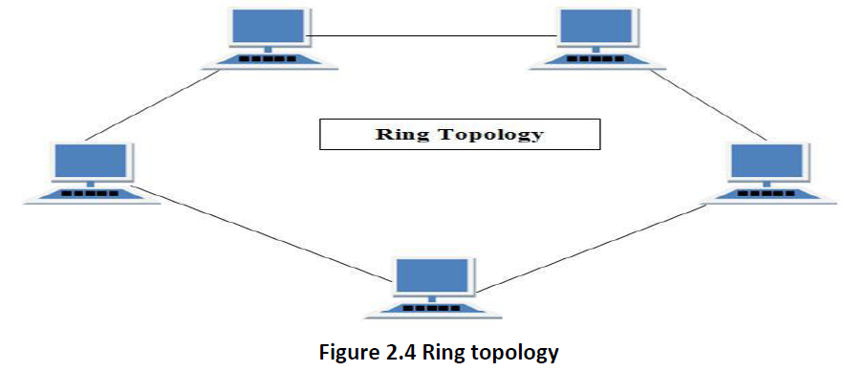

ALGORITHM:
1. Create a simulator object
2. Define different colors for different data flows
3. Open a nam trace file and define finish procedure then close the trace file, and execute nam on trace file.
4. Create six nodes that forms a network numbered from 0 to 5
5. Create duplex links between the nodes to form a STAR, Bus, Ring Topology
6. Setup TCP Connection between n(1) and n(3)
7. Apply CBR Traffic over TCP
8. Schedule events and run the program.
Example 1: Formation of Star Topology

Example 2: Formation of Bus Topology
#Creating five nodes
set node1 [$ns node]
setnode2 [$ns node]
set node3 [$ns node]
setnode4 [$ns node]
set node5 [$ns node]
#Creating Lan connection between the nodes
set lan0 [$ns newLan “$node1 $node2$node3 $node4 $node5” 0.7Mb 20ms LL Queue/FQ MAC/Csma/Cd Channel]
#Creating a TCP agent and attaching it to node 1
set tcp0 [new Agent/TCP]
$tcp0 set class_ 1
$ns attach-agent $node1 $tcp0
#Creating a TCP Sink agent for TCP and attaching it to node 3
set sink0 [new Agent/TCPSink]
$ns attach-agent $node3 $sink0
#Connecting the traffic sources with the traffic sink
$ns connect $tcp0 $sink0
# Creating a CBR traffic source and attach it to tcp0
set cbr0 [new Application/Traffic/CBR]
$cbr0 set packetSize_ 500
$ cbr0 set interval_ 0.05
$cbr0 attach-agent $tcp0
#Schedule events for the CBR agents
$ns at 0.5 “$cbr0 start time”
$ ns at 5.5 “$cbr0 stop time”
#Here we call the finish procedure after 10 seconds of simulation time
$ns at 10.0 “End”
#Finally run the simulation
$ns run

Example 3: Formation of Ring Topology
#Creating six nodes
setnode1 [$ns node]
set node2 [$ns node]
setnode3 [$ns node]
set node4 [$ns node]
setnode5 [$ns node]
set node6 [$ns node]
#Creating links between the nodes
$ ns duplex-link $node1 $node2 1Mb 15ms FQ
$ns duplex-link $node2 $node3 1Mb 15ms FQ
$ ns duplex-link $node3 $node4 1Mb 15ms FQ
$ns duplex-link $node4 $node5 1Mb 15ms FQ
$ ns duplex-link $node5 $node6 1Mb 15ms FQ
$ns duplex-link $node6 $node1 1Mb 15ms FQ\”Forms Ring Topology”

OUTPUT:

RESULT: Thus the Network topologies like Star, Bus and Ring topologies are implemented in NS@ and verified.

Exp No.: 11  Date : | IMPLEMENT AND PERFORM THE OPERATION OF CSMA/CD AND CSMA/CA USING NS2.

AIM: To implement the CSMA/CD and CSMA/CA using NS2

CSMA/CD:
The underlying protocol in Ethernet is known as the CSMA / CD – Carrier Sense Multiple Access / Collision Detection. A node which has data to transmit senses the channel. If the channel is idle then, the data is transmitted. If the channel is busy then, the station defers transmission until the channel is sensed to be idle and then immediately transmitted. If more than one node starts data transmission at the same time, the data collides.

CSMA/CA:
In contrast to CSMA/CD (Carrier Sense Multiple Access/Collision Detection) that deals with collisions after their occurrence, CSMA/CA prevents collisions prior to their occurrence.
CSMA requires each station to first check the state of the medium before initiating a transmission.

ALGORITHM:
1. Create a simulator object
2. Define different colors for different data flows
3. Open a nam trace file and define finish procedure then close the trace file, and execute nam on trace file.
4. Create six nodes that forms a network numbered from 0 to 5
5. Create duplex links between the nodes and add Orientation to the nodes for setting a LAN topology
6. Setup TCP Connection between n(0) and n(4)
7. Apply FTP Traffic over TCP
8. Setup UDP Connection between n(1) and n(5)
9. Apply CBR Traffic over UDP.
10. Apply CSMA/CA and CSMA/CD mechanisms and study their performance
11. Schedule events and run the program.

PROGRAM:
CSMA/CD
set ns [new Simulator]
#Define different colors for data flows (for NAM)
$ns color 1 Blue
$ns color 2 Red
#Open the Trace files
set file1 [open out.tr w]
set winfile [open WinFile w]
$ns trace-all $file1
#Open the NAM trace file
set file2 [open out.nam w]
$ns namtrace-all $file2
#Define a 'finish' procedure
proc finish {} {
global ns file1 file2
$ns flush-trace
close $file1
close $file2
exec nam out.nam &
exit 0
}
#Create six nodes
set n0 [$ns node]
set n1 [$ns node]
set n2 [$ns node]
set n3 [$ns node]
set n4 [$ns node]
set n5 [$ns node]
$n1 color red
$n1 shape box
#Create links between the nodes
$ns duplex-link $n0 $n2 2Mb 10ms DropTail
$ns duplex-link $n1 $n2 2Mb 10ms DropTail
$ns simplex-link $n2 $n3 0.3Mb 100ms DropTail
$ns simplex-link $n3 $n2 0.3Mb 100ms DropTail
set lan [$ns newLan "$n3 $n4 $n5" 0.5Mb 40ms LL Queue/DropTail MAC/Csma/Cd Channel]
Setup a TCP connection
set tcp [new Agent/TCP/Newreno]
$ns attach-agent $n0 $tcp
set sink [new Agent/TCPSink/DelAck]
$ns attach-agent $n4 $sink
$ns connect $tcp $sink
$tcp set fid_ 1
$tcp set window_ 8000
$tcp set packetSize_ 552
#Setup a FTP over TCP connection
set ftp [new Application/FTP]
$ftp attach-agent $tcp
$ftp set type_ FTP
#Setup a UDP connection
set udp [new Agent/UDP]
$ns attach-agent $n1 $udp
set null [new Agent/Null]
$ns attach-agent $n5 $null
$ns connect $udp $null
$udp set fid_ 2
#Setup a CBR over UDP connection
set cbr [new Application/Traffic/CBR]
$cbr attach-agent $udp
$cbr set type_ CBR
$cbr set packet_size_ 1000
$cbr set rate_ 0.01mb
$cbr set random_ false
$ns at 0.1 "$cbr start"
$ns at 1.0 "$ftp start"
$ns at 124.0 "$ftp stop"
$ns at 124.5 "$cbr stop"
# next procedure gets two arguments: the name of the
# tcp source node, will be called here "tcp",
# and the name of output file.
proc plotWindow {tcpSource file} {
global ns
set time 0.1
set now [$ns now]
set cwnd [$tcpSource set cwnd_]
set wnd [$tcpSource set window_]
puts $file "$now $cwnd"
$ns at [expr $now+$time] "plotWindow $tcpSource $file" }
$ns at 0.1 "plotWindow $tcp $winfile"
$ns at 5 "$ns trace-annotate \"packet drop\""
# PPP
$ns at 125.0 "finish"
$ns run

PROGRAM:
CSMA/CA
set ns [new Simulator]
#Define different colors for data flows (for NAM)
$ns color 1 Blue
$ns color 2 Red
#Open the Trace files
set file1 [open out.tr w]
set winfile [open WinFile w]
$ns trace-all $file1
#Open the NAM trace file
set file2 [open out.nam w]
$ns namtrace-all $file2
#Define a 'finish' procedure
proc finish {} {
global ns file1 file2
$ns flush-trace
close $file1
close $file2
exec nam out.nam &
exit 0
}
#Create six nodes
set n0 [$ns node]
set n1 [$ns node]
set n2 [$ns node]
set n3 [$ns node]
set n4 [$ns node]
set n5 [$ns node]
$n1 color red
$n1 shape box
#Create links between the nodes
$ns duplex-link $n0 $n2 2Mb 10ms DropTail
$ns duplex-link $n1 $n2 2Mb 10ms DropTail
$ns simplex-link $n2 $n3 0.3Mb 100ms DropTail
$ns simplex-link $n3 $n2 0.3Mb 100ms DropTail
set lan [$ns newLan "$n3 $n4 $n5" 0.5Mb 40ms LL Queue/DropTail MAC/Csma/Ca Channel]
Setup a TCP connection
set tcp [new Agent/TCP/Newreno]
$ns attach-agent $n0 $tcp
set sink [new Agent/TCPSink/DelAck]
$ns attach-agent $n4 $sink
$ns connect $tcp $sink
$tcp set fid_ 1
$tcp set window_ 8000
$tcp set packetSize_ 552
#Setup a FTP over TCP connection
set ftp [new Application/FTP]
$ftp attach-agent $tcp
$ftp set type_ FTP
#Setup a UDP connection
set udp [new Agent/UDP]
$ns attach-agent $n1 $udp
set null [new Agent/Null]
$ns attach-agent $n5 $null
$ns connect $udp $null
$udp set fid_ 2
#Setup a CBR over UDP connection
set cbr [new Application/Traffic/CBR]
$cbr attach-agent $udp
$cbr set type_ CBR
$cbr set packet_size_ 1000
$cbr set rate_ 0.01mb
$cbr set random_ false
$ns at 0.1 "$cbr start"
$ns at 1.0 "$ftp start"
$ns at 124.0 "$ftp stop"
$ns at 124.5 "$cbr stop"
# next procedure gets two arguments: the name of the
# tcp source node, will be called here "tcp",
# and the name of output file.
proc plotWindow {tcpSource file} {
global ns
set time 0.1
set now [$ns now]
set cwnd [$tcpSource set cwnd_]
set wnd [$tcpSource set window_]
puts $file "$now $cwnd"
$ns at [expr $now+$time] "plotWindow $tcpSource $file" }
$ns at 0.1 "plotWindow $tcp $winfile"
$ns at 5 "$ns trace-annotate \"packet drop\""
# PPP
$ns at 125.0 "finish"
$ns run

OUTPUT:

RESULT: Thus the CSMA/CD and CSMA/CA protocols are implemented using NS2 .

